**0 words in the abstract**

**2 figures**

**2 tables**

**Crossmodal Doppler Effect**

Huiting Cai1, Jinbo Zhang1, Qi Ding1, Zhenzhu Yue1*

1Department of Psychology, Sun Yat-sen University, Guangzhou, China, 510006

Running title: Crossmodal Doppler Effect

*Corresponding Authors:

Dr. Zhenzhu Yue, Department of Psychology, Sun Yat-sen University, Guangzhou, China, 510006. Email: [yuezhzh@mail.sysu.edu.cn](mailto:yuezhzh@mail.sysu.edu.cn)

**EXPERIMENT 1**

**Method**

*Participants*

Thirty reported right-handed participants took part in Experiments 1 as paid volunteers (8 males and 22 females; mean age, 20.3 years; standard deviation age, 2.2 years; range, 18-29 years). For the handiness, three mixed handiness were found in participants based on Edinburgh Handiness Inventory. Visual acuity was normal, corrected-to-normal or enough to judge the visual stimuli presented within the current study. All of the participants demonstrated normal auditory perception in the practice stage of Experiment 1. The experiment took approximately 30 min to complete.

*Apparatus*

*Materials*

*Design*

*Procedure*

**Results**

The mean RT data from Experiment 1 (see Table 1 and Figure 1) were submitted to and 2 $×$ 3 repeated measures ANOVA with types of task (Motion Direction or Pitch Change) and types of irrelevant stimuli (Congruent, Incongruent, and No) as the variables. This analysis revealed a significant main effect of task type, *F*(1,29) = 49.08, *p* < .001, $η_{p}^{2}$ = .63. The response for Pitch Change Task (*M =* 562.9*, SD =*106.5) were faster than Motion Direction Task (*M =* 660.8*, SD =* 56.9). The analysis also revealed a significant main effect of Irrelevant Stimuli Type, *F*(1,29) = 6.39, *p* < .05, $η_{p}^{2}$ = .18, with response latencies decreasing when irrelevant stimuli were congruent with task related stimuli (*M =* 601.3 *, SD =* 79.2) than incongruent and no irrelevant stimuli (*p*s < .05). And there were no significant difference between Incongruent (*M =* 618.0*, SD =* 89.0) and No Irrelevant Stimuli condition (*M =* 616.2*, SD =* 73.6), *t*(29) = 0.31, *p* = 1. The analysis of the RT data failed to reveal interaction between Task Type and Irrelevant Stimuli, *F*(1,29) = 2.55, *p* > .10, $η_{p}^{2}$ = .08, showing the effect congruency was not influenced by the Types of Task.

| *Table 1.* Mean Reaction Time (RTs, in Milliseconds) and Standard Deviation for Participants in Each Conditions. | | | | | | | | | |
| --- | --- | --- | --- | --- | --- | --- | --- | --- | --- |
| **Task Type** | **Irrelevant Stimuli** | | | **Mean** | | **SD** | | **N** | |
| Motion Direction |  | Congruent |  | 653.4 |  | 57.1 |  | 30 |  |
|  | Incongruent |  | 660.8 |  | 58.5 |  | 30 |  |
|  | No |  | 668.2 |  | 58.4 |  | 30 |  |
| Pitch Change |  | Congruent |  | 549.2 |  | 97.4 |  | 30 |  |
|  | Incongruent |  | 575.2 |  | 130.5 |  | 30 |  |
|  | No |  | 564.1 |  | 100.3 |  | 30 |  |
|  | | | | | | | | | |

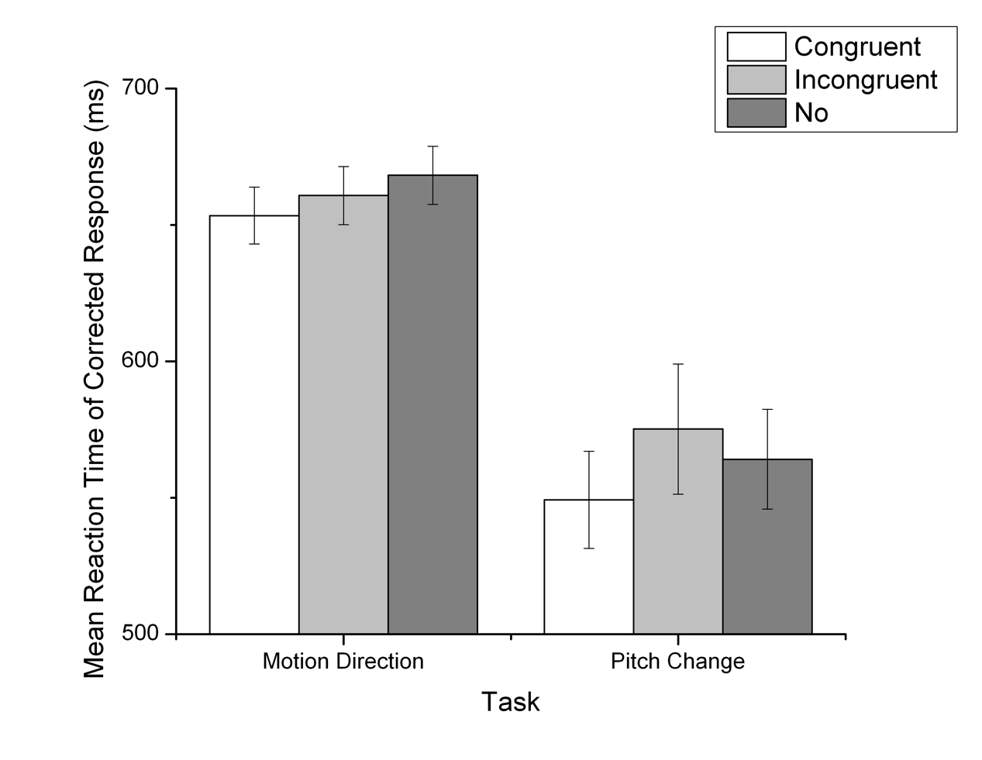

*Figure 1.* The main effect of Task Type and Irrelevant Stimuli in mean RT for Corrected Response. Error bar denotes one standard error around the mean.

A similar ANOVA was performed on the accuracy of response (see Table 2 and Figure 2). This analysis failed to reveal any main effect of Task Type, *F*(1,29) = 1.18, *p* > .10, $η_{p}^{2}$ = .04, and Irrelevant Stimuli, *F*(1,29) = 2.29, *p* > .10, $η_{p}^{2}$ = .07. However, the marginally significant interaction between Task Type and Irrelevant Stimuli were exhibited, *F*(1,29) = 2.60, *p* = .08 < .10, $η_{p}^{2}$ = .08. Further sample effect analysis showed that the accuracy of Pitch Change Task (*M =* 97.9%*, SD =*2.2%) was significant higher than Motion Direction Task (*M =* 96.4%*, SD =* 4.1%) only when Irrelevant Stimuli was congruent with task related stimuli, *t*(29) = 2.17, *p* < .05.

| *Table 2.* Percentage of Corrected Response (PC, in %) and Standard Deviation for Participants in Each Conditions. | | | | | | | | | | | | |
| --- | --- | --- | --- | --- | --- | --- | --- | --- | --- | --- | --- | --- |
| **Task Type** | **Irrelevant Stimuli** | | | **Mean** | | | **SD** | | | **N** | | |
| Motion |  | Congruent | 96.4 | |  | 4.1 | |  | 30 | |  |
|  | Incongruent | 97.1 | |  | 3.6 | |  | 30 | |  |
|  | No | 97.8 | |  | 2.2 | |  | 30 | |  |
| Pitch |  | Congruent | 97.9 | |  | 2.2 | |  | 30 | |  |
|  | Incongruent | 96.9 | |  | 3.1 | |  | 30 | |  |
|  | No | 98.0 | |  | 2.3 | |  | 30 | |  |

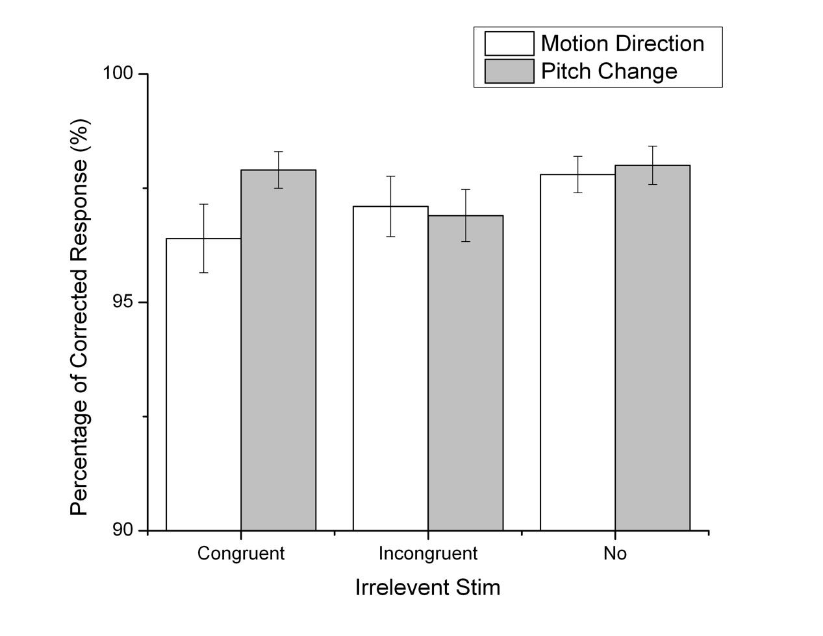

*Figure 2.* The interaction between Task Type and Irrelevant Stimuli in Percentage of Corrected Response. Error bar denotes one standard error around the mean.